Design Description
for
Tdlogv3 on ST8
Version 1.0.0
Owner: Vivek Kumar
Author(s): Vivek Kumar
Classification: Confidential (Nash Technologies certified information - Solely for authorized personnel)
Doc-Id: 00000
Status: Draft
Disclaimer
The most current version of this document is only at the Nash Technologies document repository. Any copy of this document (print or file) is uncontrolled.

Document change history
Version | Modification date | Reason | Performed by | Change request(s) | Description of change
0.1 | 10.09.2018 | Initial | Vivek Kumar | -
0.2 |  | - | - | - | -

Contents
1 Introduction 5
1.1 About this Document 5
1.2 System Requirements 5
2 General Architecture Description 6
3 Data Collector 7
3.1 Requirement 7
3.2 Design Implementation 7
3.2.1 Project Structure 7
3.3 Technology Used 7
3.4 Complete Flow Diagram 7
3.4.1 Class Diagram 7
3.4.2 Entity Diagram 8
3.5 How to Run/Compile 10
3.6 Junit test Cases 10
3.7 Rest API Simulator 11
4 Terms and abbreviations 12
4.1 Glossary 12
5 References 13

Introduction

About this Document
The Tdlogv3 library and/or application is a software component which extends a V93k test program to offer the possibility to collect data for a set of devices under test, also called touchdown and transfer them to the central database via the existing Tdlog Rest-API interface.
This Software is compatible version with Smart test 8 Java version.

System Requirements
Detailed requirement descriptions available under [1] which should be modular designed for the flowing both platforms.
Test system environment: Red Hat Enterprise Linux - RHEL7.2, Smartest 8 (Java)
Service connection: TdlogNG RestAPI

General Architecture Description
The Tdlogv3 library will receive data from test program in three phases:
a) Start a run with order data
b) Data collection:
- Start collection of die individual data
- Loop per die within a touchdown and send to API, can occur
c) End the run for this order

This data has to be send via an REST-API interface to the customers post-processing service center.
Therefore, the architecture and implementation have to consider the following key-requirements:
- no major run-time impact to the running test program
- local buffering and re-sending data records in case of delivery problems
- verification of complete uid-records
- identification of duplicated uid records.

The general function of Tdlogv3 will be the same on both V93k Test Systems (Smartest7 and Smartest8). The only difference is that the test program for Smartest 7 is designed as C++ Test Program and in Smartest 8 as java Test Program.
The complete architecture can be divided into a modular implementation concept, to split the complete functionality into major functional blocks.
- Data Collector: to receive the data from Test Program (has to be implemented as C++ and Java Application)
- Local Buffer: to buffer the received data (Maria database will be used)
- Delivery Process: to deliver the locally buffered data to the “Secure Mfg. Environment” via REST-API (will be implemented as Java Application)

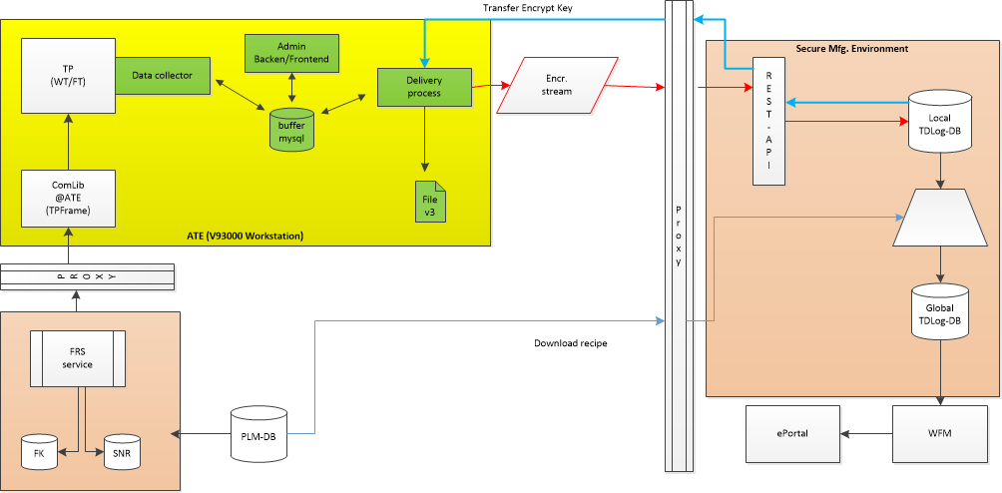
Figure 1: modular implementation concept

Data Collector

Requirement
The Data Collector will be the interface between the Test Program (TP) and the local buffer which is the Maria database. Therefore the Data Collector will provide in total 8 public interfaces for the data transfer, version check and configuration setup which will be described in the following chapters The requirement specification of the corresponding interfaces are described within the “Scope Statement Tdlog Next Generation V4.docx” [1].
To prevent redundant data the table layout is defined in the structure and dependency described in chapter 4.2.

Design Implementation
Data Collector Java version implementation is based on Chain of Responsibility principle. User/Consumer need not to know which implementer is serving their request. For more information please follow the Flow Diagram section
Abstract Data Collector
Run Finish
Run Start
Push Data Start
Push Data
Push Data End

Project Structure
It’s a maven simple maven project. Project is divided in 2 layers viz Business Layer where core implementation is done and Database Service Layer which expose different API to communicate with database.
Hibernate along with HikariCP is used for MariaDB connection and Connection pooling.
On compiling and packaging this project, jar can be used/plugin in any other project. Please refer the readme file or How to run/compile section for more information.

Technology Used
- Maven (>= 3.5.4)
- Java (8)
- Maria DB
- HikariCP (2.7.9)
- Spring boot (2.0.3. RELEASE)
- Mockito (> 2.15)
- Logback.xml

Complete Flow Diagram

Class Diagram

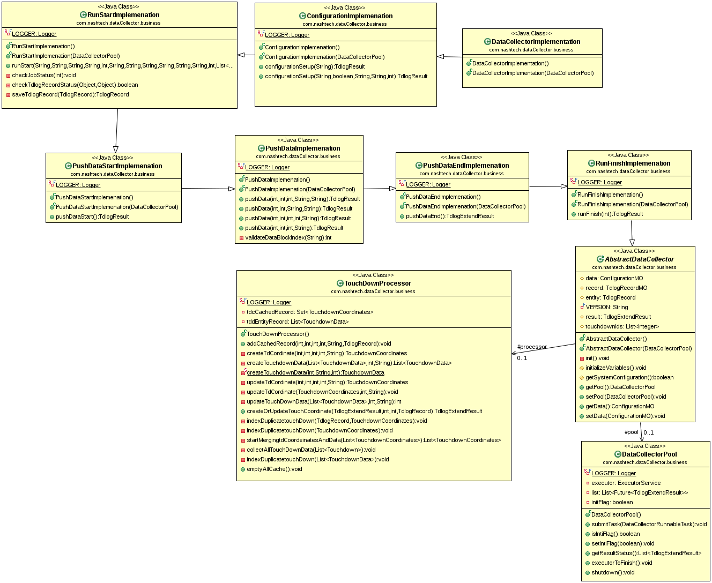

Entity Diagram

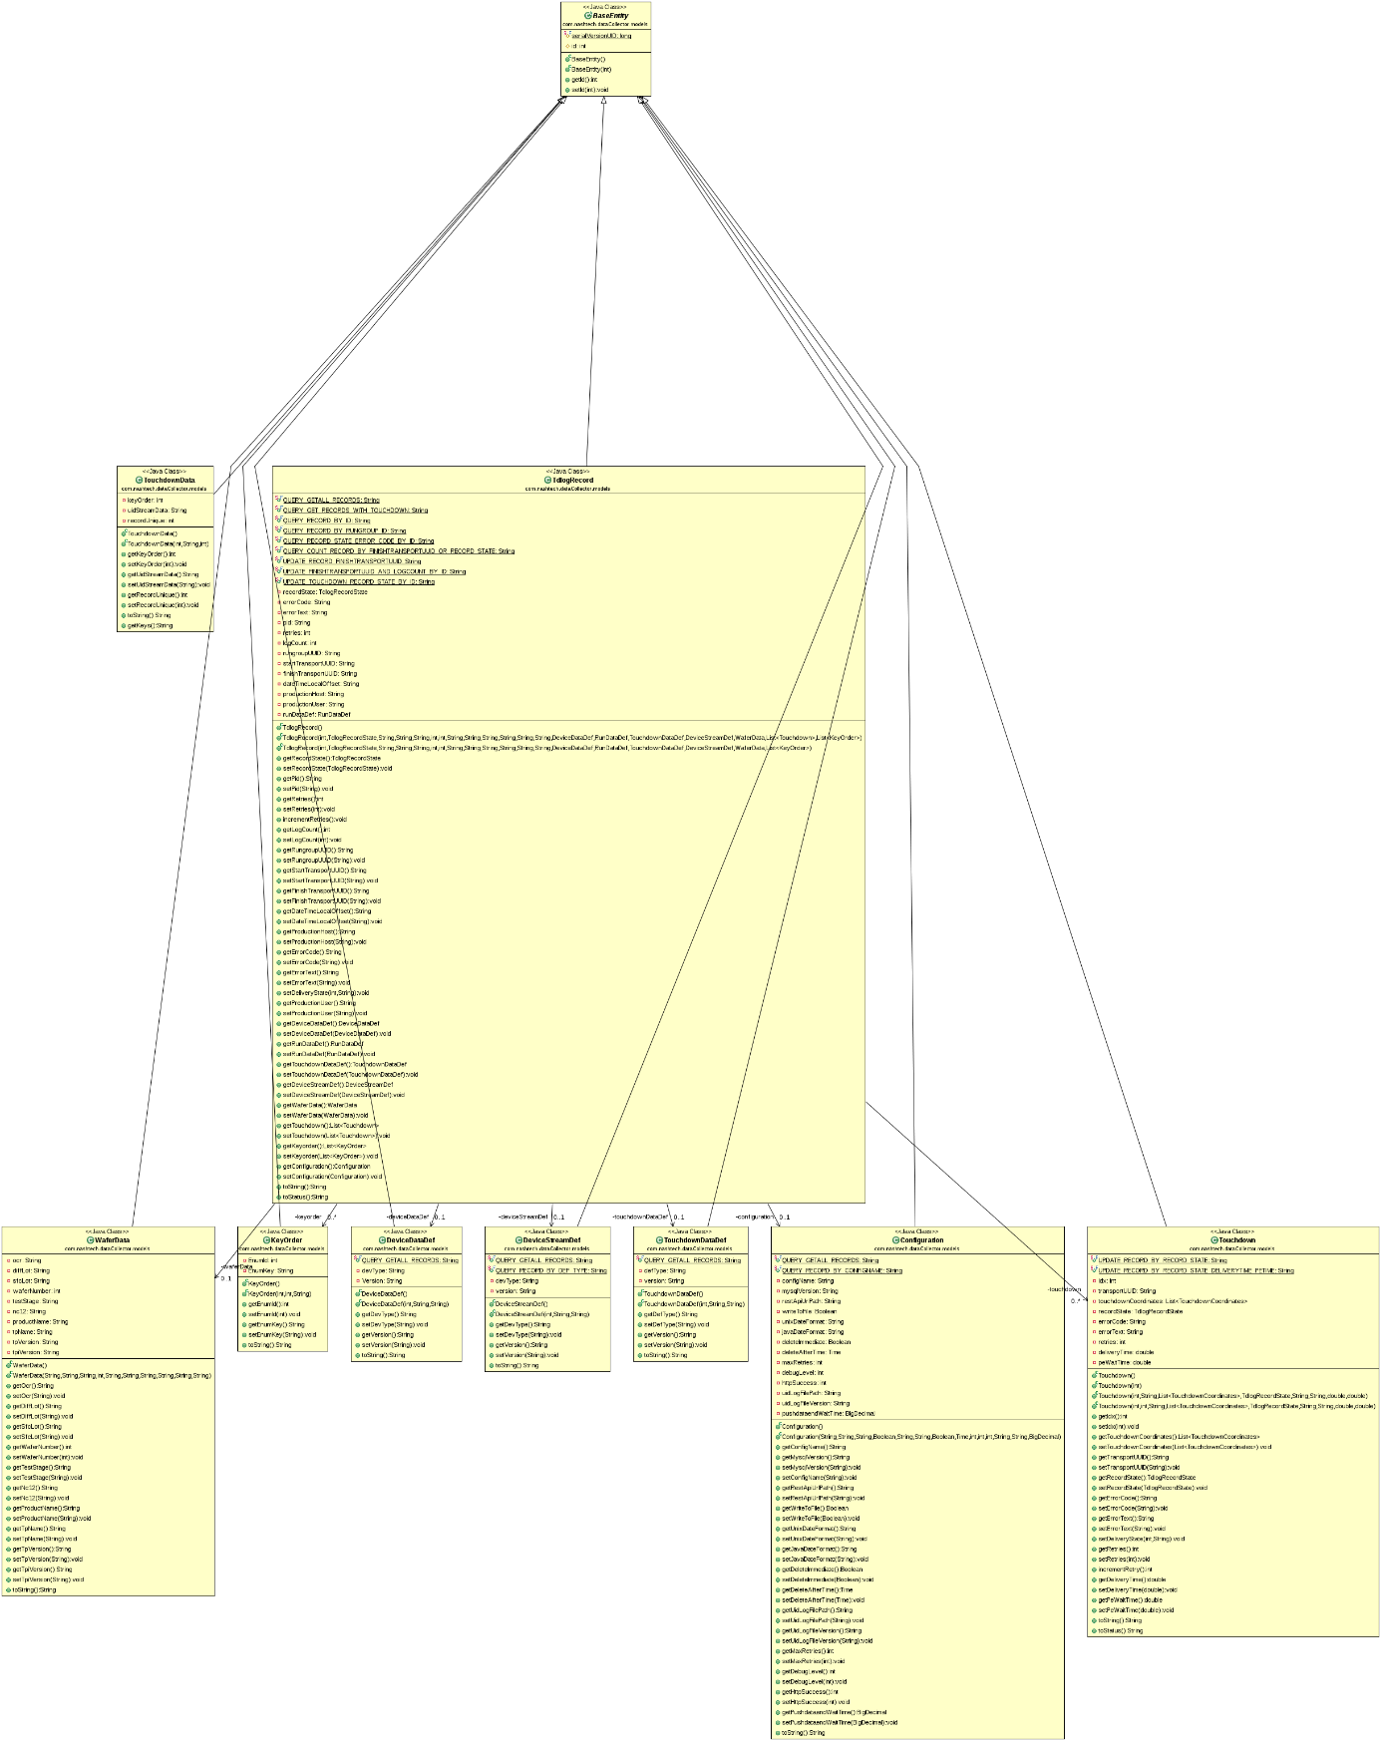

How to Run/Compile
Install maven : https://maven.apache.org/install.html
To Compile/Package :
Prerequisites
Java 8
Go on the project's root folder, then type:
$ mvn package
$ mvn -DskipTests=true package (Without test run)
$ mvn spring-boot:run

From Eclipse (Spring Tool Suite)
Import as Existing Maven Project and run it as Spring Boot App.
To Add the Jar in the local Maven Repo
mvn install:install-file -Dfile=target/dataCollector-1.0.0-jar-with-dependencies.jar -DgroupId=com.nashtech -DartifactId=dataCollector -Dversion=1.0.0 -Dpackaging=jar

Junit test Cases
For unit testing, used Mockito framework as its not possible to unit test the real database implementation.
Entry Point for these test cases is DataCollectorTest.java and provided the path in pom.xml
Unit test is divided in 2 Suite
- Valid Test case: A complete 6 valid unit test case has been provided which cover all the scenario.
- DataCollectorConfigurationValidTest
- DataCollectorRunStartValidTest
- DataCollectorPushDataStartValidTest
- DataCollectorPushDataValidTest
- DataCollectorPushDataEndTest
- DataCollectorRunFinishTest

- Invalid Test case (TODO)

- DataCollectorConfigurationInValidTest
- DataCollectorRunStartInValidTest
- DataCollectorPushDataStartInValidTest
- DataCollectorPushDataInValidTest

Rest API Simulator
Rest API Simulator is an application which in-turn uses the data Collector API’s to populate databases. This application is primarily for testing purpose.
This application is purely based on REST framework.
To Run and compile please follow section “How to Run/Compile”.
After successfully starting the application user can generate command from browser as below:
http://localhost:<portNo>/create?<td=?>&<tdc=?>
td-> Number of touch down
tdc->Number of touchdown coordinates
Example: http://localhost:8080/create?td=250&tdc=250

If user want to change the port please start the application with the following command:
“java -jar -Dserver.port=8888 <jar Name> "

Terms and abbreviations

Glossary
<optional>
<definitions of used terminology>

References

<optional>
The reference will always point to the document version which is the current valid version for the specified project or project release respectively.

- Scope Statement Linux Library for TdlogNG on PS1600 (ed.4)
- <document title 2>
<hyperlink>
- <document title 3>
- [Doc-Id <document identifier 4>] <document title 4>, <specified project | specified project release>
<author(s) 4>, Nash Technologies

